Frequently Asked Multiple Choice Questions on the AP US History Exam
(Updated 2013)

1. Common Characteristics of Pre-Columbian native Religions – Christie Byrne

The Maya, Inca, and Aztec civilizations that flourished in Central and South America provide the best insight for common characteristics of Pre-Columbian native religions. All three focused on human sacrifices, poetry writing, and large monumentals for polytheistic religion. Considered Pagan in regard to their religion, all three groups held nature in high esteem and worshipped gods linked to nature. The Mayans admired cycles of life, from weather to seasons to agriculture, which led them to create the sacred Mayan calendar. All the days of these calendars in their incredible complexity served as astronomical almanacs that rigidly controlled behavior and religious ceremony.
Religion from the Pre-Columbian times relates to the period of time filled with exploration and exploitation of foreign lands by the European powers. The Spanish longed to convert the natives to Catholicism, and many did. However, these societies kept their traditions and beliefs, notably ancestor worship. Their religion became a mixture of Catholicism and traditional elements.
The only way they felt they could gain control of natural forces such as rain or earthquakes was by appeasing the gods—that is, making the gods happy. Hoping to please the gods, they carefully fulfilled every detail of their traditional rituals (formal acts performed the same way each time as a means of religious worship) and ceremonies.

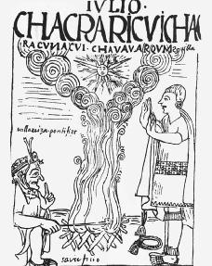

2. Motives for European exploration and conquest (esp. Columbus) – Natalie Hanson

Christopher Columbus sailed from Palos, Spain in search of a route to Asia and the Indies. Instead, he found the New World - the Americas. It didn't take long for them to realize that the Americas had great resources of its own.

After the Reformation, people had a new found faith and respects for the church. Europeans wanted to spread Christianity to other parts of the world; religion was a means of control. The more people controlled by a religion, the more power that religion had, and thus the more chance of dominance. Europeans believed they could save souls through Christian salvation and also that it was their duty to spread the word of God.

In general, wealth was a driving motivation of European exploration. The rise in new monarchs led to the competition for wealth through trade and conquering new lands. Upper class men, especially in Spain, had limited power and wanted to seek their fortune elsewhere (Americas especially). Individual explorers, such as Christopher Columbus (although he wanted to spread religion as well) wanted profit and recognition to their name. The spice market was also a huge profit of trading and several countries tried to gain control of spice trade.

Individuals and countries wanted recognition to their name. Prestige was a driving force for exploration. The more land and money a country owned, the better their chance of domination in Europe.

Colonization of America meant the takeover of Native land, leading to tensions between Natives and settlers. Resources, land, and culture was taken away from them, and eventually resulted in events like the Pueblo Revolt, in which Pueblo Indians revolted against Spanish colonizers. It is no surprise that the beginning of the nation was built of conflict with the natives, until the eventual 'equality' that was granted to them in later years.

Christopher Columbus' letter to Ferdinand and Isabella. http://www.gilderlehrman.org/history-by-era/exploration/resources/columbus-reports-his-first-voyage-1493

3. Puritan motive (build a city on a hill, i.e. provide a model) – Emily Krakow

The Puritans established New England colonies in order to establish a community of like-minded religious believers, developed a close-knit, homogeneous society. Boston, the 'city on a hill,' was created to provide a model of Christianity for the world because Puritans believed the Christianity need to be brought back to its roots. People who were predestined to be saved were living saints and those who didn't convert to Protestant were removed from the community. Nearby towns that were non-Puritan were tolerated only for the sake of trade.
During the Second Great Awakening, the idea of predestination (whether you go to hell or heaven cannot be changed by how you act while alive) was exchanged for the idea of earning a ticket to heaven through good deeds and dedication to God. Puritans were firmly against this idea and in the face of negative public opinion they moved west to spread their religion on the new frontier.
"We shall be as a city upon a hill, the eyes of all people are upon us." John Winthrop

4. The Mayflower Compact – Azima Maredia

The Mayflower Compact was the first written agreement signed by the 41 English colonists that arrived at New Plymouth in November of 1620. The settlers traveled from Britain on a ship called the Mayflower. The compact contained fair and equal laws which were meant to establish the foundation for a government. It also stated that the Pilgrims would rule themselves based on majority rule of townsmen.

The Mayflower Compact set the precedent for later documents outlining the commonwealth rule. It is also seen as the document that set the foundation for the U.S. Constitution. The Compact was the first document that truly contained democratic ideals. Therefore, when our founding fathers began drafting the U.S. Constitution, they looked to the Mayflower Compact for inspiration.
Mayflower Compact 1620
IN The Name of God, Amen. We, whose names are underwritten, the Loyal Subjects of our dread Sovereign Lord King James, by the Grace of God, of Great Britain, France, and Ireland, King, Defender of the Faith, &c. Having undertaken for the Glory of God, and Advancement of the Christian Faith, and the Honor of our King and Country, a Voyage to plant the first colony in the northern Parts of Virginia; Do by these Presents, solemnly and mutually in the Presence of God and one another, covenant and combine ourselves together into a civil Body Politick, for our better Ordering and Preservation, and Furtherance of the Ends aforesaid; And by Virtue hereof do enact, constitute, and frame, such just and equal Laws, Ordinances, Acts, Constitutions, and Offices, from time to time, as shall be thought most meet and convenient for the general Good of the Colony; unto which we promise all due Submission and Obedience. In WITNESS whereof we have hereunto subscribed our names at Cape Cod the eleventh of November, in the Reign of our Sovereign Lord King James of England, France, and Ireland, the eighteenth and of Scotland, the fifty-fourth. Anno Domini, 1620
John Carver Edward Tilley Degory Priest
William Bradford John Tilley Thomas Williams
Edward Winslow Francis Cooke Gilbert Winslow
William Brewster Thomas Rogers Edmund Margeson
Issac Allerton Thomas Tinker Peter Browne
Myles Standish John Rigdale Richard Britteridge
John Alden Edward Fuller Georoe Soule
Samuel Fuller John Turner Richard Clarke
Christopher Martin Francis Eaton Richard Gardiner
William Mullins James Chilton John Allerton
William White John Crackston Thomas English
Richard Warren John Billington Edward Dotey
John Howland Moses Fletcher Edward Leister
Stephen Hopkins John Goodman

5. The Half-way Covenant – Suzanne Lightsey

The Half-Way Covenant, created by New England Puritans in 1662, provided a partial church membership for the children and grandchildren of church members. Those who accepted the Covenant and agreed to follow the creed within the church could participate in the Lord's supper. Crucially, the half-way covenant provided that the children of holders of the covenant could be baptized in the church. These partial members, however, couldn't accept communion or vote. Puritan preachers hoped that this plan would maintain some of the church's influence in society, and that these 'half-way members' would see the benefits of full membership, be exposed to teachings and piety which would lead to the "born again" experience, and eventually take the full oath of allegiance. Many of the more religious members of Puritan society rejected this plan as they felt it did not fully adhere to the church's guidelines, and many of the target members opted to wait for a true conversion experience instead of taking what they viewed as a short cut.

This compromise was accepted only by some New England congregations. Political forces within the colonies tended to support the relaxation of church membership rules since the right to vote on civil matters was reserved for the Visible Saints. By mid-century, many prominent founding families were being excluded from leadership positions, which spurred them to support changes in standards. The essential solidarity of the early Puritan communities had fallen away. A split had developed between the fundamentalists, who wanted to maintain religious purity at any cost, and the more liberal thinkers, who believed that a stronger society could be built by including more people.

Revival of religious fervor-
"June the 15 , I rode out to Mr. Throop’s a new Society in Norwich, and preach’d one Sermon for him, to a full Assembly. There seem’d to be a great listning to the Word; great Concern appear’d in the Countenances of many; a great Number were in Tears, and several cried out: Some fainted away, and one or two rag’d. After the Sermon was over I took Pains to find out the Spring of that Distress which appeared in many Instances, and I think, they gave Grounds to judge it was from Conviction of Sin; except those Instances that were distress’d with their out-rageous Passions."

6. Motive of those settling Virgina (seek profit) – Shannon Lu

The colony in Jamestown, Virginia was founded by the joint-stock company, the Virginia Company of London, for profitable reasons. The colony expanded the English market, their territorial claims, and new resources such as tobacco. Since those who settled the colony were seeking profit, they remained loyal to the royal crown as they relied on England for economic stability.
Since those who settled Virginia were seeking profit, they failed to set up a stable government and to realize that the Powhatans lived on the land they planned to settle. Unhappy with the government and their failure to protect settlers against Native Americans, Nathaniel Bacon started Bacon's Rebellion.
"wee woulde vouchsafe unto them our licence to make habitacion, plantacion and to deduce a colonie of sondrie of our people into that parte of America commonly called Virginia."
-Virginia Charter

7. The Headright system – Walker Register

Back in Jamestown (1607), people started to realize there wasn't much gold in eastern North America. Investors for Jamestown (1607) were all like "well this stinks. Where is all the gold? I'm pulling my money out." So Jamestown was losing money and supplies and the people of Jamestown (1607) were turning to selling tobacco because when your financial plans fall apart you can always turn to selling drugs. However, tobacco was a serious cash crop and Jamestown (1607) was able to bring in some money, but Jamestown (1607) needed a system to divide land... So they made the headright system.
The headright system was made in 1618. People already living in Virginia were granted 2 head rights (100 acres). People who payed their way had 1 head right (50 acres). Then rich people began to pay for indentured servants to come over and pay off their debt by tending the plantation.
This lead ultimately into slavery because plantation owners realized it was much easier to have unpaid workers who work for you forever than have some guy work for you constantly asking for raises and eventually leaving you to tend to the farm yourself.
Oh hey look, a helpful link
http://www.u-s-history.com/pages/h1153.html

8. Origins of Chesapeake slavery – Syndey Criswell

Slavery began in the Chesapeake region, centered on Virginia and Maryland, in 1619 when a Dutch ship brought 20 men from Africa to Jamestown, Virginia. The slaves were meant to buffer the weakened white workers and indentured servants. At first, the new slaves and the indentured servants had similar rights but in the second half of the 1600s the colonies made laws that gave slaves less rights, defined slavery as life long, passed on to children and based on race.

This event is important because it is the introduction of Africans to the United States. The slave population rapidly grew creating a sizeable sub population of people descended from slaves brought over from Africa. This shaped future American history including, 3/5 Compromise, southern plantation culture, the Civil War, Bloody Kansas, and the Civil Rights Movement.

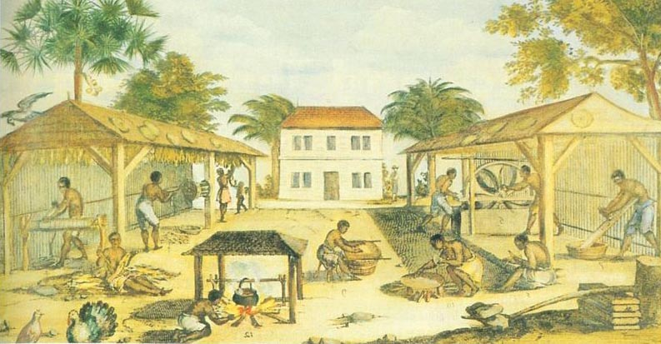
9. Bacon’s Rebellion – Sarah Pacinda

Due to the drop in tobacco prices, more trade competition, restrained English trade, and heighten prices for English goods, the people of Jamestown were becoming more and more irritable when governor Berkeley's attempts to control the Native Americans. Berkeley's abundant spending for defense against Indians that were actually friendly and picking of favorites in regards to trade led to Bacon trying to take things into his own hands. Berkeley and Bacon began butting heads when Bacon created his own following of people to fight against Berkeley and the Indians. When his attempts to take over failed, Bacon showed his frustration when he burned down Jamestown. The people of Virginia, not surprisingly, abandoned Bacon in his attempts to stop Berkeley.
Bacon's Rebellion stirred up even more conflict with Natives around the Virginia area. People began to spread more and more into Native territories with their built-up defenses. And because Blacks, Whites, and indentured servants all took part in the rebellion, there were conflicts about the difference in the rights each group had.
http://www.nps.gov/jame/learn/historyculture/bacons-rebellion.htm

10. Anglicization – Hannah Moulton

Anglicization was the colonial American desire to conform to English society such as English tastes in food, customs, and architecture. Factors that prompted anglicization: colonists had self-governing political communities based on English models, commercial and legal ties to England, the printing press allowed the colonies and England to trade Enlightenment ideas, Protestantism, and more religious tolerance.

Anglicization in the colonies led to the creation of: the House of Burgesses in Virginia (the first democratically-elected legislative body in the colonies), the Mayflower Compact, and Maryland Toleration Act which granted religious tolerance to Christians who recognized the Holy Trinity.

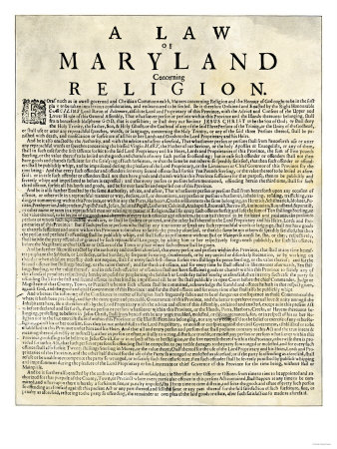
Maryland Toleration Act

11. The Pueblo Revolt (Pope’s Rebellion) – Madison Stueve

In 1680, Pueblo's rebelled against Spanish Lords in the South West. After 8 decades of living under Spanish rule, a group of pueblo rebels fought back and dominated the Spanish missionaries. Many priests died.
The pueblo revolt was one of the early examples of rebellion for religious and racial purposes. The pueblo revolt was significant because the Pueblo's destroyed all Christian objects to purge their homeland. They also introduced revivalism- to go back to the traditional ways before the Spanish came.
"Even though I am not ordering them to prepare the mud and make adobe bricks, there are always many other tasks and ways in which they can offer assistance, and by doing so they will be serving God and the king."
-A report from Spanish California, 1776

12. Quakers/William Penn motives – James Beiter

13. 1st Great Awakening (Ivy League colleges founded by New Lights) – Tera Gadecke
The Great Awakening was an religious movement that swept Protestant Europe, British America, and especially the American colonies in the eighteenth century. During the Great Awakening a number of new Protestant churches were established which left a permanent impact on American Protestantism. During the great Awakening there was an emerging group of Clergymen called New Lights who defended the Great Awakening for reinvigorating American religion. New lights founded Ivy leagues like Harvard(established in 1639).

The first and second great awakening occurred in two different time periods, but they both had the same general focus. The focus of the first and second great awakening was to question actions, beliefs and ideas that were considered the social norm at that time. During the first and second great awakening, the most prevalent questions that arose had to do with authority figures. During both times society challenged authority figures.

Website where I found primary source document ( this is a quote I pulled from the primary source document) this quote was by Jonathan Edwards.

"Ever since the great work of God that was wrought here about nine years ago, there has been a great abiding alteration in this town in many respects. There has been vastly more religion kept up in the town, among all sorts of persons, in religious exercises and in common conversation than used to be before. There has remained a more general seriousness and decency in attending the public worship. There has been a very great alteration among the youth of the town with respect to reveling, frolicking, profane and unclean conversation, and lewd songs. Instances of fornication have been very rare. There has also been a great alteration among both old and young with respect to tavern haunting. I suppose the town has been in no measure so free of vice in these respects for any long time together for this sixty years as it has been this nine years past."

14. Jonathan Edwards – Sinners in the Hands of an Angry God – Maddie Sue Jakubik

"Sinners in the Hands of an Angry God" is a sermon written by Jonathan Edwards. It explains vivid imagery of Hell with observations of the world and quotes from the Bible. It goes along with the theology of the Great Awakening.
This speech was a part of the movement of the first Great Awakening. The first Great Awakening was a religious revival in the American colonies of the 18th century during which a number of new Protestant churches were established. This brought reform to the Christian faith and led to more change in the 2nd Great Awakening.
“That the reason why they are not fallen already and do not fall now is only that God's appointed time is not come. For it is said, that when that due time, or appointed time comes, their foot shall slide. Then they shall be left to fall, as they are inclined by their own weight. God will not hold them up in these slippery places any longer, but will let them go; and then, at that very instant, they shall fall into destruction; as he that stands on such slippery declining ground, on the edge of a pit, he cannot stand alone, when he is let go he immediately falls and is lost.”
― Jonathan Edwards, Sinners in the Hands of an Angry God

15. Deism – Audrey Brown

Deism is the belief in the existence of a supreme God, specifically of a creator who does not intervene in the universe. Deists consider God a remote being that, after creating the universe, withdrew from involvement with the human race. It isn't a religion, it's a religious philosophy. It emerged during the enlightenment in the 17th and 18th centuries.

In the 1790's less than 10% of white Americans belonged to a church. People started rejecting the idea of predestination which led to the Second Great Awakening. Deism led to a time period when it was common for a family to not attend any church, which was very unlike the fundamental beliefs of many of the religious groups. This time period proved that the need for some kind of reform was visible.

“I have observed, indeed, generally, that while in protestant countries the defections from the Platonic Christianity of the priests is to Deism, in catholic countries they are to Atheism. Diderot, D'Alembert, D’Holbach, Condorcet, are known to have been among the most virtuous of men. Their virtue, then, must have had some other foundation than the love of God."

[Letter to Thomas Law, 13 June 1814]”
― Thomas Jefferson, Letters of Thomas Jefferson

16. Albany Congress, 1754 (Franklin, first attempt to unite colonies – failed) – Sarah Kimery

The Albany Congress (1754) was a meeting of representatives sent by the legislatures of the British colonies of Connecticut, Maryland, Massachusetts, New Hampshire, New York, Pennsylvania, and Rhode Island. Representatives met everyday in Albany, New York from June 19 to July 11, 1754 to discuss the problems with Native Americans and the threat of the French and Indian war. This meeting of all the colonies was the first of it's kind, and was used for the Stamp Act and the First Continental Congress, which foreshadowed the American Revolution.

Primary source: Albany Plan of Union from Benjamin Franklin's papers, http://www.constitution.org/bcp/albany.htm

17. Legal rights of women (Colonial Era) – Avery Shepherd

Women in the colonial era had very little rights. They were not allowed to vote or own land in their names, and had almost as little freedom as slaves. Husbands often beat their wives, which was legal at the time, and if a wife chose to runaway from the marriage, husbands would post advertisements for their capture.
In 1848, the Seneca Falls convention created the Declaration of rights for women. Women like Elizabeth Cady Stanton argued for equality and Fredrick Douglas, an advocate for African American rights, supported them greatly. People finally began to recognize women's rights which began a progression in equality over the next century.
"Do not put such unlimited power into the hands of the husbands. Remember all men would be tyrants if they could. If particular care and attention is not paid to the ladies we are determined to foment a rebellion, and will not hold ourselves bound by any laws in which we have no voice, or representation."
-Abigail Adams, (1744-1818) First Lady and advocate of women’s rights
https://www.nwhm.org/education-resources/history/quotes
18. Stamp Act/Stamp Congress – Connor Downing

Passed by British Parliament in 1765 without consent of American colonists. All American colonists required to pay a tax on every piece of printed paper they used. Ship's papers, legal documents, licenses, newspapers, other publications, and playing cards were taxed. Colonists were mad because tax was seen as a way to raise funds for Britain, not to regulate commerce.

After victories in both the 7 years war and the French & Indian war Britain had a national debt of £130,000,000. Britain sought to solve the debt of war and stationing 10,000 soldiers around the Appalachian mountains by taxing the colonists with the Stamp Act. These debts would lead to more taxes than the stamp act leading to unrest before the revolutionary war.
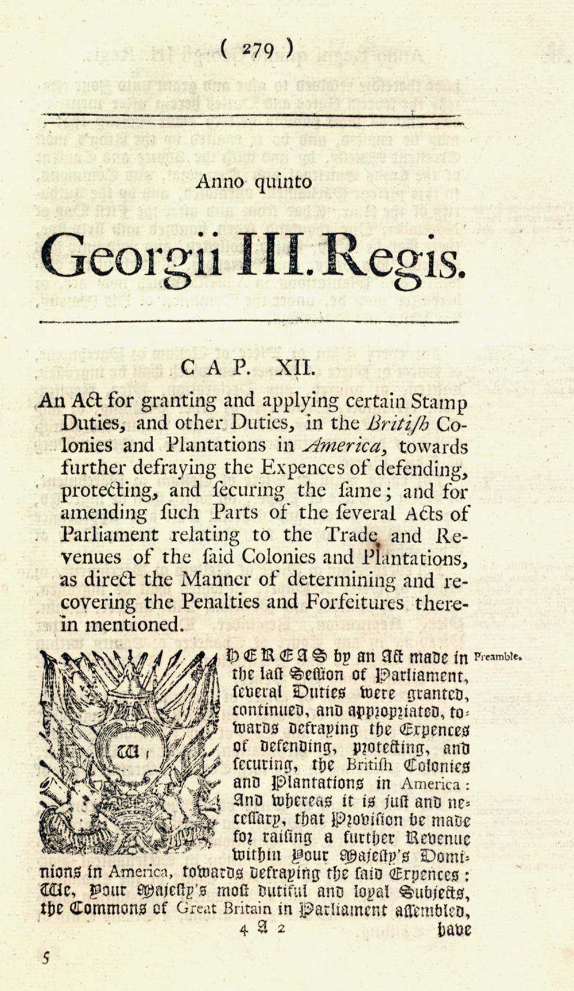
19. Slavery in pre-independence times – Robert Ehle

Though not very prominent in the middle of northern colonies, slavery was a main part of the southern colonies' economy. Slavery was in the colonies since the 1620s but did not become apparent in the last parts of the 17th century. The first public document against slavery was the 1688 Petition, it was also one of the first documents to define "universal human rights." By 1776, 20% of the total population of the colonies was composed by slaves. The southern economy relied extensively on the work of slaves. The work that a slave did varied from owner to owner but for the most part it stayed with agricultural harvesting.
Before the US acquisition of its independence and its use of slaves, slaves had been used throughout the world not exclusive to the US. The earliest documentation of slavery was around 11,000 years ago during the Neolithic Revolution. The first slaves to touch US soil were led to Jamestown in the year 1619. This would be a precursor for the many more slaves to come to the United States up until the passing of the 13th amendment in 1864. Still to this day, countries around the world are banning slavery, the last country to do so was Mauritania in 2007.
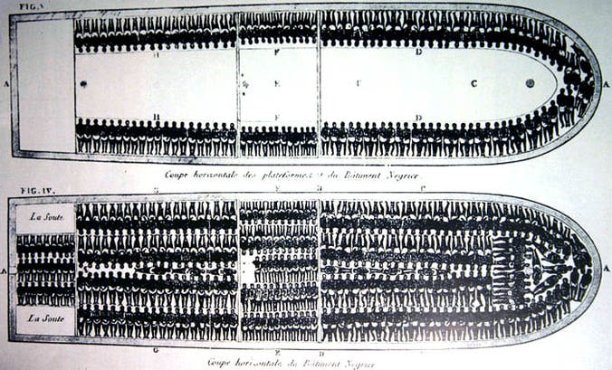

20. Indentured servants (all the rage prior to slavery) – Clara Miertschin

Indentured servitude was the system in which poor peasants were essentially paid to be slaves for a certain period of time. It was most prevalent in colonial British America. The system died out when slaves from Africa began to be more abundant.
Indentured servitude paved the way for slavery in North America. Indentured servitude remained legal until 1948. Indented servitude was also practice in Africa and Caribbean.
The following is an indentured servitude contract:
Fourth Day of August in the Twenty-ninth Year of the Reign of our Sovereign Lord George the Second King of Great Britain, &, And in the Year of our Lord, One Thousand Seven Hundred and fifty five __ Between William Buckland of Baford Carpenter & Joiner of the one Part, and Thomson Mason of London, Esq. of the other Part, Witnesseth, That the said William Buckland for the Consideration herein after-mentioned, hath, and by these Presents doth Cove- nant, Grant, and Agree to, and with the said Thomas Mason Executors and assigns, That He the said William Buckland shall and will, as a faithful Cove- nant Servant, well and truly serve the said Thomas Mason his Executors and assigns in the Plantation of Virginia beyond the Seas, for the Space of Four Years, next ensuing his Arrival in the said Plantation in the Employ- ment of a Carpenter and Joiner. And the said William Buckland doth hereby Covenant and Declare him self, now to be the Age of Twenty two Years Single and no Covenant or contracted Servant to any other Person or Per- Sons, And the said Thomas Mason for himself his Executors Or Assigns, in Consideration thereof, doth hereby Covenant, Promise And Agree to and with the said William Buckland his Executors, and Assigns, that He the said Thomas Mason his ___________________ Executors or Assigns, shall and will at his or their own proper Costs and Charges, with what convenient Speed they may, carry and convey, or cause to be carried and convey- ed over unto the said Plantation, the said Wm Buckland __ and from henceforth, and during the said Voyage, and also during the said Term, shall and will at the like Costs and Charges, provide for and allow the said Wm Buckland all necessary _____________ Meat, Drink, Washing, Lodging, ____________ fit and convenient for Wm as Covenant Servants in such Cases are usually provided for and allowed and pay and allow William Buckland Wages on Salary at the Rate of Twenty Pounds Sterling per Annum Payable Quarterly And for the true Performance of the Premisses, the said Parties, the these Presents bind themselves, their Executors and Administrators, the either to the other, in the Penal Sum of Forty Pounds Sterling, firmly by these Presents. In witness whereof, they have hereunto interchanged by set their Hands and Seals, the Day and Year above-written.
21. Proclamation of 1764 – Kendall Chase

The French and Indian War ended in 1763 and it removed several ominous barriers and opened up a host of new opportunities for the colonists. The first thing in the minds of the colonists was the great western frontier that had opened to them when the French ceded that contested territory to the British. The royal proclamation of 1763 did much to dampen the celebration of open barriers. The proclamation mainly closed off the frontier to colonial expansion. The king and the council presented the proclamation to calm the fears of the Indians who felt that they would be driven from their land due to the colonists expanding westward. The proclamation provided that all lands west of the heads of all rivers which flowed into the Atlantic Ocean from the west or northwest were off-limits to the colonists. This excluded the rich Ohio Valley and all territory from the Ohio to the Mississippi rivers from settlement. The proclamation also established four new colonies including Quebec, East Florida, West Florida and Grenada. Most of the proclamation is devoted to the subject of Indians and Indian lands. It asserted that all of the Indian peoples were under the protection of the King. It required that all lands within the "Indian territory" occupied by Englishmen were to be abandoned. It included a list of prohibited activities, provided for enforcement of the new laws, and indicted unnamed persons for fraudulent practices in acquiring lands from the Indians in times past.

22. Stamp Act Crisis – Nick Neighbors

On November 1, 1765 the British ministry issued the stamp act, requiring colonists to pay a tax for many common goods and meanwhile being unrepresented. This triggered a huge reaction by the colonists; crowds calling themselves the Sons of Liberty stopped stamped papers from being unloaded from British ships. Colonists started making goods such as cloth themselves instead of importing it, and protest petitions started circulating. The colonies soon sent delegates to form the Stamp Act Congress, and regulate the taxes by the colonies for the colonies.

This event connects to the revolution and the the Declaration of Independence. Many taxes during this time where frustrating colonists, most of the taxes where caused by expenses in the French and Indian War. Taxation without representation frustrated many colonists and even drove them to the point of the Stamp Act crisis as shown previously. With continues pressure from Britain for things like this, it was only a matter of time until a revolution, and in this case 1776.
Official British document primary source concerning stamp act:

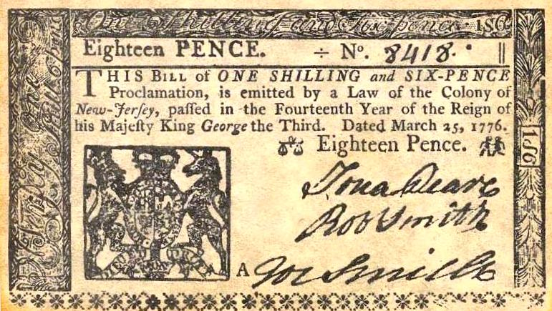

23. Boston Massacre – Michael Millan

24. Sons of Liberty/Boston Tea Party – Jonathan Cramer

The sons of liberty were essentially a group amongst the colonist that took a stand against British tyranny and their supreme mandates. The Boston tea-party was one major occurrence that revealed colonists anger. Many men of the sons of liberty dresses up as native Americans and tosses hundred of crates of tea from British import ships into the ocean.
This resistance Immediately gave British a reason to force their iron rule down even further, passing acts that came to be known as the intolerable acts in 1774. As a result, the relationship between colonists and the British were irreparable thus giving the colonists stronger devotion for independence and ultimately a major cause of the American Revolution.
"The natural liberty of man is to be free from any superior power on Earth, and not to be under the will or legislative authority of man, but only to have the law of nature for his rule." - Samuel Adams.

25. Significance of the French Alliance during American Revolution – Jay Dreifurst

26. Articles of Confederation – Elliot Flores

It is perhaps best to think of the Articles of Confederation as the predecessor to our current Constitution of the United States. In short, these documents would explain and draw out the roles of federal and state government in the newly-made United States. States in the United States were not officially apart of any federal government, but instead were described as "a coalition of states who support each other for their common good." In essence, as its' name suggests, the country was rather confederated in its conception, having no real sense of unity aside from an army when it was required. As such, the Articles of Confederation suffered from several shortcomings an numerous inefficiencies, such as a lack of official federal agencies, the lack of ability for the government to implant any sort of national system of taxation, and the requirement of an overwhelming majority of agreement in order for new legislation to be put into effect. These inefficiencies would see themselves out, and eventually be called to be revised in 1787, leading to the Second Continental Congress and the drafting of the Constitution.
Transcript of the Articles of Confederation:
http://faculty.washington.edu/qtaylor/documents_us/articles_of_confederation.htm
Library of Congress synopsis:
http://www.loc.gov/rr/program/bib/ourdocs/articles.html

27. Shay’s Rebellion
28. The Virginia Plan
29. Ratification Controversy – Katy Roberts

Ratification controversy refers to the discrepancy between parties at the constitutional convention and afterward. Antifederalists opposed the constitution, and some protested that replacing the Articles of Confederation was illegal. Federalists were convinced that that the Constitution would prevent civil strife. Both sides tried to advocate their opinions through newspapers, pamphlets, and public meetings.
Ratification controversy is an idea that still occurs today, shown by the fact that things take a long, long time to pass in congress. Examples of this include The Bill to Abolish the Slave Trade (15 years), Civil Rights Act (a year), and the Affordable Care Act (which hasn’t ever passed-- but has been repealed 33 times). Party members still adamantly declare and fight for their opinions, and the stubbornness of most parties leads to prolonged discussion and decision.
http://www.archives.gov/education/lessons/constitution-day/images/
delaware.gif
30. Bill of Rights (1st 10 Amendments to Constitution, protecting individual liberties, and giving states the powers not directly given to the feds) – Austin Martin

The Bill of Rights is a collection of the first ten amendments to the U.S. Constitution. The purpose of these ten amendments was to comfort the anti-federalists who were not in favor of ratifying the constitution. The Bill of Rights establishes some personal freedoms, limits the power of the government in judicial proceedings, and gives some power to the state and people.

The Bill of Rights is important in its time period because it helped pioneer the way for personal liberty in general along with government policies and documents that reflect higher enlightenment ideals. In the late 18th century, most governments were autocratic and did not resemble philosophy's concerning self-achievement or personal accomplishment.
Ninthly, That article 7th be numbered as article 8th. From Madison's letter to congress
The first of these amendments relates to what may be called a bill of rights. I will own that I never considered this provision so essential to the federal constitution, as to make it improper to ratify it, until such an amendment was added; at the same time, I always conceived, that in a certain form, and to a certain extent, such a provision was neither improper nor altogether useless. I am aware, that a great number of the most respectable friends to the Government, and champions for republican liberty, have thought such a provision, not only unnecessary, but even improper; nay, I believe some have gone so far as to think it even dangerous. Some policy has been made use of, perhaps, by gentlemen on both sides of the question: I acknowledge the ingenuity of those arguments which were drawn against the constitution, by a comparison with the policy of Great Britain, in establishing a declaration of rights; but there is too great a difference in the case to warrant the comparison: therefore, the arguments drawn from that source were in a great measure inapplicable. In the declaration of rights which that country has established, the truth is, they have gone no farther than to raise a barrier against the power of the Crown; the power of the Legislature is left altogether indefinite. Although I know whenever the great rights, the trial by jury, freedom of the press, or liberty of conscience, come in question in that body, the invasion of them is resisted by able advocates, yet their Magna Charta does not contain any one provision for the security of those rights, respecting which the people of America are most alarmed. The freedom of the press and rights of conscience, those choicest privileges of the people, are unguarded in the British constitution.
31. Attitude of founding fathers towards political parties (Jeff “We’re all feds, we’re all reps) – Trevor Brown

John Adams, Benjamin Franklin, Alexander Hamilton, John Jay, Thomas Jefferson, James Madison, and George Washington. These men were known as the seven founding fathers of the United States of America. These men believed that political parties would only destroy representative government and that there should be no place for parties in American democracy. This did not stop the people of America from creating political parties though. This is seen in the Jefferson era when Thomas Jefferson eases the tension between the Federalists and the Republicans which had a fiery hate for each other which is part of the reason that these men didn't like these parties. These founding fathers wanted us to be a country of togetherness, not a country torn apart by two sides.

Connection to another time period: Even presidents today see this anger between two parties. Our presidents over the past few years like Obama and Bush have given similar speeches to Jefferson's inaugural address. They say things like "We aren't a country of Democrats and Republicans, but a country of Americans!" This is the same message that Jefferson was trying to get across in his inaugural address.

Primary Source- Part of Thomas Jefferson's First Inagural Address:

"But every difference of opinion is not a difference of principle. We have called by different names brethren of the same principle. We are all republicans--we are all federalists. If there be any among us who would wish to dissolve this Union or to change its republican form, let them stand undisturbed as monuments of the safety with which error of opinion may be tolerated where reason is left free to combat it. I know, indeed, that some honest men fear that a republican government cannot be strong; that this government is not strong enough. But would the honest patriot, in the full tide of successful experiment, abandon a government which has so far kept us free and firm, on the theoretic and visionary fear that this government, the world's best hope, may by possibility want energy to preserve itself? I trust not. I believe this, on the contrary, the strongest government on earth." -Thomas Jefferson

32. Hamilton’s economic plans – Tyler Albrecht
33. Jay’s Treaty – Henrik Olsson

Jay's Treaty was a 1795 treaty between the United States and Great Britain that is credited with averting war, resolving issues remaining since the Treaty of Paris of 1783, which ended the American Revolutionary war. The terms of the treaty were designed primarily by Secretary of the Treasury Alexander Hamilton. The treaty gained the primary American goals which included the withdrawal of British Army units from pre-Revolutionary forts that had failed to relinquish in the Northwest Territory of the United States. The Americans were granted limited rights to trade with British possessions in India and colonies in the Caribbean in exchange for some limits on the American export of cotton. Washington's announced support proved decisive and the treaty was ratified by a 2/3 majority of the Senate in November 1794.

The Rush-Bagot Treaty was a treaty between the United States and Britain limiting naval armaments on the Great Lakes and Lake Champlin, following the War of 1812. This treaty is much like Jay's treaty in that they are both demilitarizing the British here in the United States. The treaty provided for a large demilitarization of lakes along the international boundary, where many British naval arrangements and forts remained. The treaty stipulated that the United States and British North America could each maintain one military vessel no more than 100 tons, as well as one cannon, on Lake Ontario and Lake Champlin. The remaining Great Lakes permitted the United States and British North America to keep two military vessels

"His majesty will withdraw all his troop and garrisons from all posts and places within the boundary lines assigned by the treaty of peace to the United States. This evacuation shall take place on or before the first day of June, one thousand seven hundred and ninetysix, and all the proper measures shall in the interval be taken by concert between the Government of the United States and His Majesty's Governor-General in America for settling the previous arrangements which may be necessary respecting the delivery of the said posts:" - Thomas Jefferson

34. XYZ Affair – Alex Mendrys

An American diplomatic commission was sent to France in July 1797 to negotiate problems that were threatening to break out into war. The diplomats were approached by agents of the French foreign minister and they demanded an unneutral loan of 32 million florins, plus what added up to a bribe of $250,000 just because they talked with Talleyrand. The American trio knew that bribes were normal in Europe but they gagged at paying a quarter of a million dollars for just talking with no assurance of a settlement. The negotiations quickly broke down and then left France without ever engaging in formal negotiations.
The failure of the commission caused a political firestorm in the United States when the commission's dispatches were published. It led to the undeclared Quasi-War (1798 to 1800). Federalists who controlled the government took advantage of the national anger to build up the nation's military. They also attacked the Jeffersonian Republicans for their pro-French stance, and Elbridge Gerry for what they saw as his role in the commission's failure.

35. Alien and Sedition Acts – Sanjeev Nookala

36. Virginia and Kentucky Resolutions – Fabian Nava

The Virginia Resolution was written by James Madison and the Kentucky Resolution was written by Thomas Jefferson both in response to the Alien and Sedition Acts. These papers argued that the government had no authority to use powers not specifically delegated to it in the Constitution. They said that with the Alien and Sedition Acts the government was not only using powers not given to it but instead using powers that were forbidden in one of the amendments to the Constitution. In the Kentucky Resolution Jefferson also argued that the states had the power to nullify federal laws that they found unconstitutional.

During the nullification crisis of the late 1820s Vice President John C. Calhoun used these documents to argue against a high tariff that was imposed on imported British textiles, which benefited the northern textile industry but lowered British demand for southern cotton and raised prices of textiles in the south. He claimed that the states had the right to nullify laws they found unconstitutional and not beneficial for their sovereign interests. This led to the South Carolina Ordinance of Nullification which declared the tariff null in South Carolina. President Jackson saw this as so much of a threat that he asked Congress for permission to send federal troops to enforce the nullified laws. Congress led by Henry Clay introduced a compromise bill which revised the tariff and avoided an armed confrontation.

37. Marbury v. Madison – Zoe Brown

38. Louisiana Purchase – why? Control mouth of Mississippi – Margy Arendes

The Louisiana Purchase was a land deal between the United States and France, in which the U.S. acquired about 827,000 square miles of land west of the Mississippi River for $15 million dollars. It gave the US control of the mouth of the Mississippi River.

President Jefferson's plans for western expansion and access to international markets were threatened when France regained control of Louisiana. Napoleon, a leader who emerged from the French Revolution, threatened to block American access to the port of New Orleans on the Mississippi River. However, he needed money to continue his war against Britain. Knowing that he couldn't force Americans out of the land, Napoleon offered Louisiana to the U.S. for $15 million dollars.

“There is on the globe one single spot, the possessor of which is our natural and habitual enemy. It is New Orleans.” -President Thomas Jefferson

39. Embargo Act, Non-Intercourse Act, Macon’s Bill #10 – Miles Bearden

The Embargo Act of 1807 disallowed any and all exports from the U.S. This was done to make Britain and France respect American rights. The Embargo Act was highly unpopular and led to the shutting down of New England ports and an increase in unemployment rates. The Non-Intercourse Act replaced the Embargo Act in 1809 during Jefferson's last days as president. The Non-Intercourse Act made exporting to only Britain and France illegal. This was also mostly ineffective and damaged the economy. Macon's Bill #1 (also 1809) forbade imports coming from France and Britain, but said if either country would respect American commerce rights then the restrictions would be lifted for that country.
These acts were created in the midst of the Napoleonic Wars; the United States wanted to trade with both Britain and France and remain neutral in the war. Obviously though, neither side wanted the other to have American supplies. The goal was to use economic coercion to avoid war, however, these 3 all contributed to causing the War of 1812.
Primary Source: Jefferson's Defense of the Embargo Act of 1807
https://www.gilderlehrman.org/collections/a0b3698e-1084-412b-9073-485164806320

40. Hartford Convention – JoJo Rockwood

The Hartford Convention was various meetings starting December 15th 1814 and ending January 5th 1815 located in Hartford, Connecticut. The meetings included New England Federalists discussing the War of 1812 that was currently happening at the time. Their worries included the problems with political power and the threat of the federalist government increasing power. They discussed the Louisiana Purchase, three-fifths compromise, and the embargo of 1807.
After the convention ended Andrew Jackson had a victory in New Orleans, as well as the signing of the Treaty of Ghent, that created disgrace and dislike against the Federalists that eventually led to the ejection of the Federalist Party as a major national political force. Although they had been eliminated the Federalists were still incorporated in some places to political power in places like Massachusetts until 1823 when they were no longer involved.
Primary Source- http://www.teachushistory.org/war-1812-hartford-convention/resources/short-account-hartford-convention

41. Tecumseh and War of 1812 – Brooke Thompson

Tecumseh was the Shawnee Chief and military leader in the war of 1812. The War of 1812 was a military conflict, lasting for two-and-a-half years, fought by the United States of America against the United Kingdom of Great Britain and Ireland, its North American colonies, and its American Indian allies.It began over alleged British violations of American shipping rights, such as the impressment of seamen — the forcing of American merchant sailors to serve on British ships. American soldiers attacked Canada unsuccessfully in the war, and the British retaliated by burning the White House and other buildings in Washington D.C. War of 1812 ended in the treaty of Ghent signed on December 24, 1814 returned all territorial conquests made by the two sides.

The United States declared war on June 18, 1812 for several reasons, including trade restrictions brought about by the British war with France, the impressment of American merchant sailors into the Royal Navy, British support of Indian tribes against American expansion, outrage over insults to national honor after humiliations on the high seas, and possible American interest in annexing British territory in modern-day Canada.

Treaty of Ghent:

"There shall be a firm and universal Peace between His Britannic Majesty and the United States, and between their respective Countries, Territories, Cities, Towns, and People of every degree without exception of places or persons. All hostilities both by sea and land shall cease as soon as this Treaty shall have been ratified by both parties as hereinafter mentioned. All territory, places, and possessions whatsoever taken by either party from the other during the war, or which may be taken after the signing of this Treaty, excepting only the Islands hereinafter mentioned, shall be restored without delay and without causing any destruction or carrying away any of the Artillery or other public property originally captured in the said forts or places, and which shall remain therein upon the Exchange of the Ratifications of this Treaty, or any Slaves or other private property; And all Archives, Records, Deeds, and Papers, either of a public nature or belonging to private persons, which in the course of the war may have fallen into the hands of the Officers of either party, shall be, as far as may be practicable, forthwith restored and delivered to the proper authorities and persons to whom they respectively belong. Such of the Islands in the Bay of Passamaquoddy as are claimed by both parties shall remain in the possession of the party in whose occupation they may be at the time of the Exchange of the Ratifications of this Treaty until the decision respecting the title to the said Islands shall have been made in conformity with the fourth Article of this Treaty. No disposition made by this Treaty as to such possession of the Islands and territories claimed by both parties shall in any manner whatever be construed to affect the right of either."

42. Eli Whitney (interchangeable parts to rifle, cotton gin) – Erin Beadle

Eli Whitney was an American inventor best known for his invention of the cotton gin and the interchangeable parts to a rifle. The cotton gin was created in 1793. A single cotton gin could generate up to 55 pounds (25 kg) of cleaned cotton daily. This contributed to most of the economic development of the United States. This also increased the enslavement of African Americans in the United States. Whitney's other invention which was interchangeable parts for a rifle was invented in 1798. Every part of the musket was replaceable with an identical piece. The easy interchangeability allows a faster repair and assembly of new devices, but also minimizes time and skill to create the muskets.
The cotton gin was created to produce cotton at a faster rate. It led to increased numbers of slaves. Before the cotton gin, slavery was declining and after it was introduced it rejuvenated the plantation slavery industry. Which eventually causes the Civil War (1861-1865). The south depended more on cotton and slavery, while the north depended more on industry than agriculture. This became a major difference in economic attitudes which ultimately led to the north relying on all social classes working together, and the south still holding onto social order ( south = pro-slavery & north = against slavery)
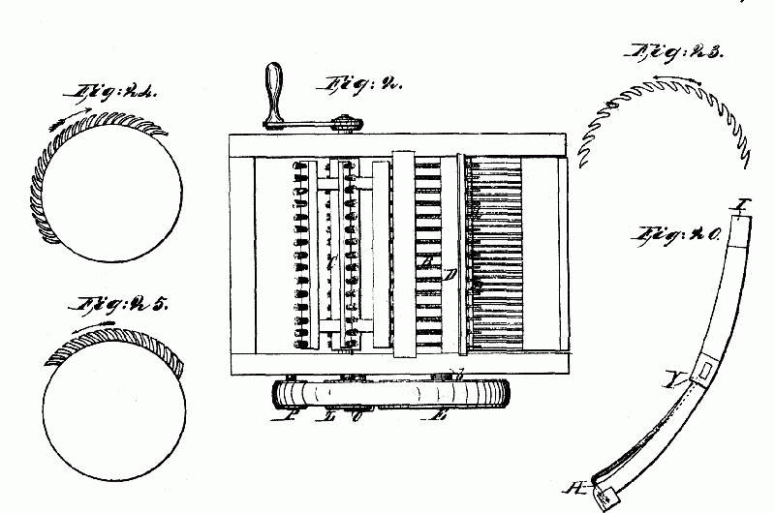

43. Panic of 1819
44. Missouri Compromise
45. Henry Clay’s “American System” (high tariffs, BUS, federal funding of internal improvements)
46. Monroe Doctrine
47. Andrew Jackson (Indian removal, veto Congress, opposes nullification, opposes BUS, supports Westward expansion)
48. Indian Removal Act/Trail of Tears
49. Nullification, John C. Calhoun, Tariff of Abominations (1828)
50. Utopian Communities/Transcendentalists/Brook Farm/Oneida/Owenites
51. Ralph Waldo Emerson (stressed individuality, self-reliance)
52. Hudson River School of Art
53. Alexis DeTocqueville’s Democracy in America
54. Horace Mann
55. Panic of 1837
56. Cult of Domesticity
57. Seneca Falls/Elizabeth Cady Stanton/Declaration of Sentiments
58. William Lloyd Garrison, “The Liberator” – abolitionist
59. Harriet Tubman – Underground Railroad
60. Harriet Beecher Stowe’s Uncle Tom’s Cabin
61. Dred Scott v. Sandford, 1857 (slave is not a citizen, slave is property, Missouri Compromise is dead)
62. Popular Sovereignty
63. Kansas-Nebraska Act
64. Douglas’s Freeport Doctrine (popular sovereignty can exclude slavery anywhere)
65. The Election of 1860 – Republican Platform, etc.
66. Primary cause of Civil War (maintain the union)
67. Emancipation Proclamation, 1863 – gave North the moral high ground, calculated to win support of Britain & France)
68. Wade Davis Bill
69. Radical Reconstruction
70. 13th, 14th, and 15th Amendments
71. Scalawags
72. Compromise of 1877 (ends Reconstruction in South)
73. Knights of Labor
74. John Gast’s American Progress
75. Helen Hunt Jackson’s A Century of Dishonor
76. Dawes Act, 1887 (assimilate Indians into mainstream America – kill tribal identity)
77. Ghost Dance
78. Andrew Carnegie’s Gospel of Wealth

79. Henry George’s Progress and Poverty
80. Walter Rausenbusch’s Social Gospel
81. Populists – farmers’ party, wanted “free silver”
82. William Jennings Bryan’s Cross of Gold speech
83. Yellow Journalism (Hearst, Pulitzer – called for war with Spain. “Remember the ‘Maine’”)
84. Alfred Thayer Mahan’s The Influence of Sea Power on History
85. “New Immigration” – from SE Europe, after Civil War (Gilded Age)
86. Emma Lazarus, The New Colossues
87. Jacob Riis, How the Other Half Lives
88. Jane Addams, Hull House and Settlement House Movement
89. Open Door Policy (open access to China for American investment)
90. W.E.B. DuBois and Booker T. Washington
91. NAACP
92. Muckrakers (Sinclair Lewis, Mother Jones, Ida Tarbell, Ida B. Wells)
93. Teddy Roosevelt (Square Deal, Conservation Movement, Panama Canal)
94. William H. Taft accomplishments
95. Germany’s unrestricted submarine warfare (main reason for U.S. joining WWI)
96. Wilson’s 14 Points (Article X). Wilson lost vote in Senate because he wouldn’t compromise on wording. Senate didn’t want US totally tied to L of N charter)
97. Scopes Monkey Trial
98. Bonus Army, 1932 (give us our bonus now!)
99. 100 Day Congress, New Deal
100. Civilian Conservation Corps
101. Wagner Act
102. Indian Reorganization Act
103. Franklin Roosevelt’s Four Freedoms Speech
104. Rosie the Riveter
105. GI Bill
106. Zoot Suit Riots
107. Double victory in World War II
108. 1948 Election – Truman’s Civil Rights Platform
109. Containment Policy
110. Korean War DMZ
111. Levittown
112. Cuban Missile Crisis
113. Brown v. Board of Education (overturned Plessy v. Ferguson)
114. Little Rock Central High School
115. Beatniks, especially Jack Kerouac’s On the Road
116. Sputnik, 1957 – arms and space race, education recives greater emphasis in the U.S.
117. Sit-ins, 1960, Greensboro, NC (seeking integration of public facilities)
118. Civil Rights Acts of 1960, 1964
119. Malcolm X
120. Voting Rights Act of 1965 (Poll Tax and Literacy Tests outlawed)
121. Miranda v. Arizona
122. Barry Goldwater
123. Betty Friedan’s The Feminine Mystique
124. Michael Harrington’s The Other America
125. Rachel Carson’s Silent Spring
126. Gulf of Tonkin Incident (and Resolution – gave LBJ a free hand to escalate Vietnam War)
127. Watergate
128. Tet Offensive, 1968
129. Camp David Accords (Carter, Begin and Sadat, peace in Middle East)
130. Iranian Hostage Crisis
131. Persian Gulf War – Kuwait

