Chapter 1 Name ___________________________
“New World Beginnings”
The American Pageant

The Shaping of North America (page 5)

1. How did glacial action shape the physical landscape of North America?

Peopling the Americas (pages 5-8)

2. How did the Great Ice Age contribute to early human migration into North America?

The Earliest Americans (pages 8-10)

3. When and where did corn (maize) cultivation begin?

When did it reach present-day American Southwest?
When did it reach the Atlantic seaboard region of North America?

4. How did corn cultivation change societies?

5. What was life like for the majority of native peoples who lived in small, scattered, and impermanent settlements?

Indirect Discoverers of the New World (pages 10-11)

6. Who were the first Europeans to land in North America? Why didn’t their settlements last long?

7. Why are Christian crusaders considered indirect discoverers of the New World?

Europeans Enter Africa (pages 11-13)

8. Why was the development of the caravel important to travel along the African coast?
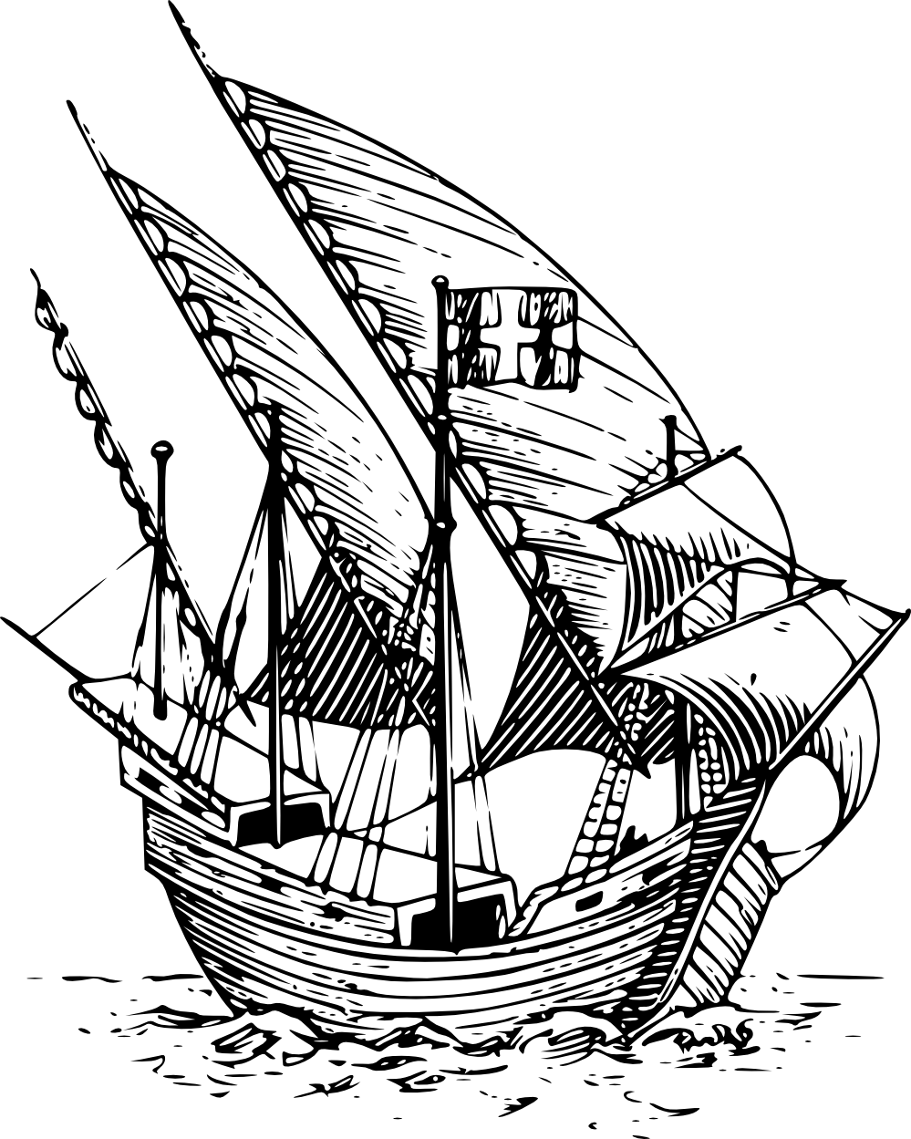

9. In what way did Arab and later Portuguese slave trading practices foster the extinction of regional African cultures and tribal identities?

10. Why was the newly united kingdom of Spain (under Ferdinand and Isabella) forced to look to the west for a water route to India?

Columbus Comes upon a New World (pages 13-14)

11. What factors set the stage for Columbus’ voyage and the historical shift that it brought?

12. Why is Columbus called “one of the most successful failures in history?”

When Worlds Collide (pages 14-15)

13. What do you think are the two most important products that the New World gave to the Old World? Why?

a.

b.

14. What do you think are the two most important products that the Old World gave to the New World? Why?

a

b.

The Spanish Conquistadores (pages 16-17)

15. What was the importance of the 1494 Treaty of Tordesillas?

16. What were the Spanish seeking in the New World?

17. What is the significance of each of the following?

a. Juan Ponce de Léon

b. Francisco Coronado

c. Hernando de Soto

d. Francisco Pizarro

18. What was the encomienda system?

The Conquest of Mexico (pages 20-21)

19. What two factors made it relatively easy for Cortés to prevail over the Aztecs?

a.

b.

20. How does the author describe the “distinctive culture of mestizos?”

The Spread of Spanish America (pages 21-24)

21. What two reasons are given for the Spanish decision to fortify the northern periphery of New Spain?

a.

b.

22. Give two examples of conflict between the Spanish and Native Americans in the upper Rio Grande.

a.

b.

23. What was the primary focus of the Spanish in California?

24. Why does the author suggest that the “Black Legend” is a false concept?

